Interacting with, exploring, knowing and using my environment.

**Learning outcome:**

Exploring and knowing my immediate environment

**Competence:**

Identifies people, animals, plants and other things at learning centre.

**Lesson 1**

**Suggested materials**

* Visual
* Charts
* Chalkboard

**Procedure:**

Discuss with the learners about the people found at school.

**Rhyme:**

Teacher teacher x2

Teacher is good,

Teacher is smart

I love my teacher.

**Activity:**

Let the learner match and tell the people found at school.

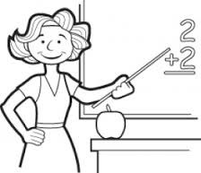 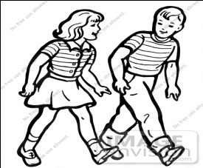

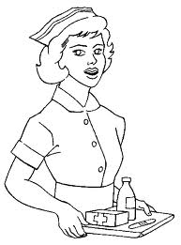 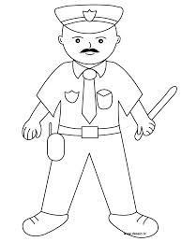

 

 

**LESSON 2**

**Learning outcome:**

Knowing and exploring my immediate environment.

**Competence:**

I can identify things found in the class.

**Suggested materials:**

* Charts
* Chalk board
* Real objects

**Procedure:**

Discuss with the learners about things found in the class.

**Rhyme:**

A teacher has a pencil

A nice nice pencil x 2

A pencil has a rubber to

Rub in the book

**Activity:**

Let the learner copy things found in the class.

|  |  |  |  |  |  |  |
| --- | --- | --- | --- | --- | --- | --- |
|  | HH01672_ |  | 119542307725783745open_book_john_olsen_01 |  | BD04915_ |  |
| cup | chair | Tin | book | box | pencil | pen |

**LESSON 3**

**Learning outcome:**

Knowing and exploring my immediate environment

**Competence:**

I can identify things found in the class.

**Suggested materials:**

* Charts
* Visual aid
* Chalk board
* Real objects

**Procedure:**

Discuss with the learners about things found in the class.

**Rhyme:**

A teacher has a pencil

A nice nice pencil x 2

A pencil has a rubber to

Rub in the book

**Activity**

Let the learner match things found in the class.

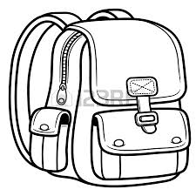 chair

 pencil

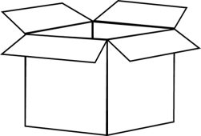 bag

BD04915_ book

HH01672_ box

**Lesson 4**

**Learning outcome:**

Knowing and exploring my immediate environment

**Competence:**

I can identify things found in the class.

**Suggested materials**

Charts Visual aid Chalk board Real object

**Procedure:**

Discuss with the learners about things found in the class.

**Rhyme:**

Teacher teacher x2

Teacher is good,

Teacher is smart

I love my teacher.

**Activity:**

Let the learners circle the words of things found in class.

 bag chair

 ball book

Pen cup

 tin cup

axe tin

**LESSON 5**

**Learning outcome:**

Knowing and exploring my immediate environment.

**Competence:**

I can identify things found in the class.

**Suggested materials;** Charts**,** Visual aid**,** Chalkboard**,** Real objects

**Procedure:**

Discuss with the learners about things found in the class.

**Rhyme:**

A teacher has a pencil

A nice nice pencil x 2

A pencil has a rubber to

Rub in the book

**Activity:**

Let the learner name things found in the class.

book \_\_\_\_\_ HH01672_\_\_\_\_\_ \_\_\_\_ \_\_\_\_

**LESSON 6**

**Learning outcome:**

Exploring and knowing my immediate environment.

**Competence:**

Identifies people, animals, plants and other things at learning centre.

**Suggested materials:**

* Visual aid
* Charts
* Chalkboard illustration

**Procedure:**

Discuss with the learners about people found at school.

Copy and learn

|  |  |  |  |  |
| --- | --- | --- | --- | --- |
| ANd9GcRha3iP-S4GccQzs2VwoHgvlcDFeMBaHWMOCiILzEgUAeNJxYx0 | ANd9GcQQvY_sjBMm97NWjZbFnjufmWV3VYzK5nwmoD-3iwZCCS6cimOj | https://encrypted-tbn1.gstatic.com/images?q=tbn:ANd9GcSE6NfycjHYvdZsLvd3ReYaA1uhrMDr4F5Ipk3fuX41IPWmltujlw | C:\Users\waps\Pictures\2013-12-20 1\1 001.jpg | Image result for girl images clip art black and white |
|  |  |  |  |  |

**LESSON 7**

**Learning outcome:**

Exploring and knowing my immediate environment.

**Competence:**

I can identify people, animals, plants and other things at learning centre.

**Suggested materials:**

* Visual
* Charts
* Chalkboard

**Procedure:**

Discuss with the learners about wild animals e.g lion, zebra, giraffe, elephant etc.

**Rhyme:**

Elephant, elephant

Go to the bus,

No no no

Why why why,

Because am too big

And the bus is small

Oh shake body x 2

**Activity:**

Let the learner copy and draw the wild animals.

Lion zebra elephant

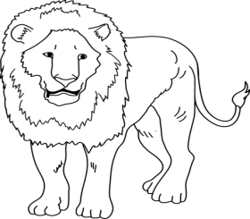 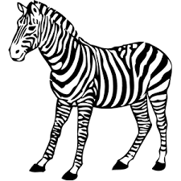 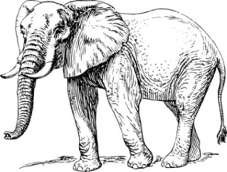

**LESSON 8**

**Learning outcome:**

Exploring and knowing my immediate environment.

**Competence:**

I can identify domestic animals at the learning centre. E.g dog, cat, cow, pig

**Suggested materials.**

* Charts
* Visual aids
* Chalkboard

**Procedure:**

Discuss with the learners about domestic animals and their sounds.

**Rhyme:**

Cow cow cow

You are my friend,

You give us milk,

You give us meat,

Thank you cow

You are my friend

**Activity:**

Let the learners copy and draw the domestic animals.

|  |  |  |  |
| --- | --- | --- | --- |
| Awesome-Drawing-of-Cow-Coloring-Page  Cow | goat | dog-clip-art-black-and-white-dog_02A_outline  Dog | cat |
|  |  |  |  |

**LESSON 9**

**Learning outcome:**

Exploring and knowing my immediate environment.

**Competence:**

I can identify domestic animals.

**Suggested materials:**

* Visual
* Charts
* Chalkboard

**Procedure:**

Discuss with the learners about animals and their sounds.

**Rhyme:**

Moo- moo,

Listen to the cow x 3

Moo, moo, that is its sound

**Song:**

Moo moo

There is a little cow,

Far in the forest

Singing very sweetly

And dance very nice x 2

**Activity:**

Let the learner copy animals and their sound.

Cow – moo –moo

Goat – mee mee

Cat – mew mew

Sheep – baa baa

Dog – bow bow

**LESSON 10**

**Activity**

Let the learner match animals to their sounds.

Cow bow bow

Goat baa baa

Cat moo moo

Sheep mee mee

Dog mew mew

**LESSON 11**

**Learning outcome:**

Knowing and exploring my immediate environment

**Competence:**

I can identify domestic birds and wild birds e.g hen, duck, cock, parrot etc

NB: wild birds e.g crested crane, ostrich

**Suggested material:**

* Visual aid
* Charts
* Chalkboard

**Procedure:**

Discuss with the learners about wild and domestic birds.

**Song:**

Ten little birds standing on a tree

I stoned one and then they were nine

Nine little birds ---

**Rhyme:**

Two little black birds,

Sitting on the wall,

One named Peter

One named Paul

Fly away Peter

Fly away Paul

Come back Peter

Come back Paul

And sit on the wall.

**Activity:**

Let the learner copy and draw the same domestic birds.

|  |  |  |  |
| --- | --- | --- | --- |
| ANd9GcS50q3OeSaLgllrVmBD4Q5UyUsfHPUNcX0qCnyJUnWow2NQQ6UE7g  duck | AN02341_hen | cock | Parrot |

**LESSON 12**

**Learning outcome:**

Knowing and exploring my immediate environment.

**Competence:**

I can identify plants e.g banana plant, maize plant, cassava plant etc

**Suggested materials**

* Visual aid
* Chalkboard

**Procedure:**

* Discuss with the learners about plants.

**LESSON 13**

**Learning outcome:**

Knowing how to keep and take care of my environment.

**Competence:**

I know how to keep and clean my environment

**Suggested materials;**

* Visual
* Charts
* Cut outs

**Procedure:**

Discuss with the learners about how to keep our environment clean for example by sweeping the compound, by mopping the house, by cleaning toilets, by burning rubbish.

**Rhyme:**

Cleaner is sweeping x 2

What a happy cleaner

You can see

**Activity**:

Let the learner shade different people cleaning the environment

|  |  |  |  |
| --- | --- | --- | --- |
| ANd9GcQQvY_sjBMm97NWjZbFnjufmWV3VYzK5nwmoD-3iwZCCS6cimOj | http://jontambek.files.wordpress.com/2012/03/74042-royalty-free-rf-clipart-illustration-of-a-black-silhouetted-maid-woman-mopping-a-floor.jpg | ANd9GcQ-BgoX7aMWRmkRGoGRDqYK9UDOVtlvUn5WT7C9QjZj0oxQS0dJ | Boys-slashing-grass-at-scho |

**Rhyme:**

Cassava cassava

What a nice food!

When I eat cassava

I get energy

Paw paw tree x 2

Can you give me paw paw?

Hungry hungry, I am very hungry

If you give me a paw paw

I will not be hungry

**Activity**

Let a learner copy and draw the same plants.

|  |  |  |
| --- | --- | --- |
|  | images (2) |  |
|  |  |  |

**Activity 2**

Let the learners match the same plants

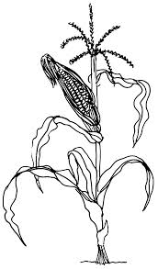 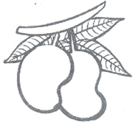

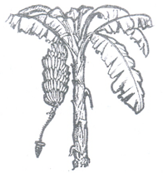 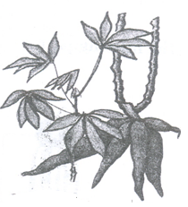

 

 

**Activity 3**

Let the learners match the same people cleaning the environment

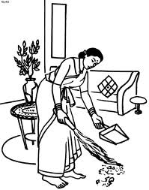 digging

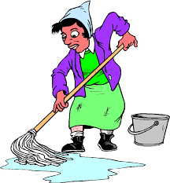 slashing

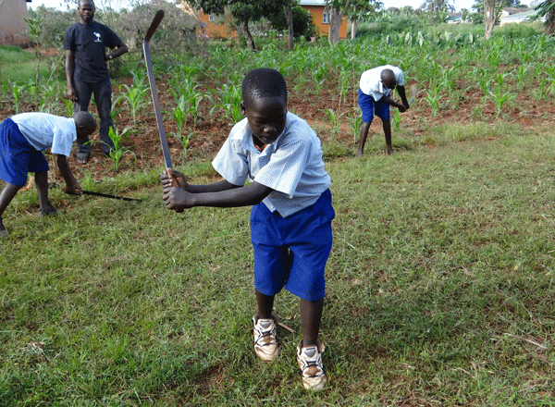 sweeping

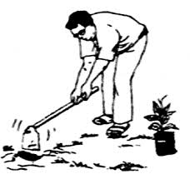 mopping

**Activity 4**

Let the learners copy the same people cleaning the environment

sweeping  digging

MORE PRACTICE WORK TERM I

**LEARNING AREA 2 (ENGLISH)**

**Copy the same**

|  |  |  |  |  |  |  |  |  |  |  |  |  |  |  |  |
| --- | --- | --- | --- | --- | --- | --- | --- | --- | --- | --- | --- | --- | --- | --- | --- |
| a | b | c | d | e | f | g | h | i | j | K | l | M | n | o | p |
|  |  |  |  |  |  |  |  |  |  |  |  |  |  |  |  |
| q | r | s | t | u | v | w | x | y | z |

**Match the same**

a e

b d

c a

d c

e b

**Match the same**

f j

h i

g h

i f

**Match and write**

k o --------

l n ------

m k -------

n l ---------

o m ---------

**Circle the given letter**

a g I b f

b a h g I j b d m f

**Circle the same**

a b a

c c d

g h h

i j j

**Copy and draw**

|  |  |  |  |
| --- | --- | --- | --- |
| chair | bag | girl | book |
|  |  |  |  |

**Name these picture**

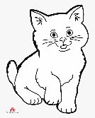 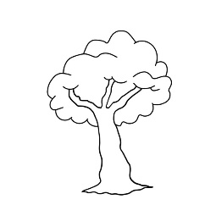 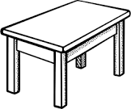 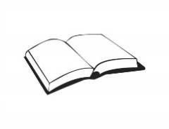

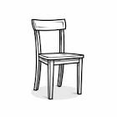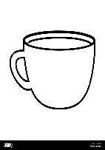 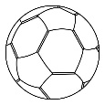 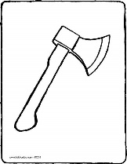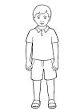 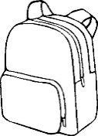

**Read and draw**

|  |  |  |  |  |
| --- | --- | --- | --- | --- |
| book | egg | bed | chair | Cup |
| tin | ball | cat | pot | Fish |

**Read and match**

sun 

tin 

pot 

cup 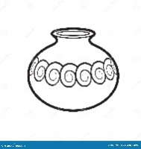

tree

**Preposition**

 on  in

**Match correctly**

 Under

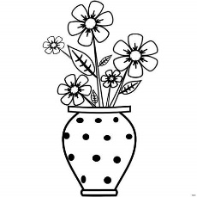 On

**** In

**Colours**

**Read and shade**

|  |  |
| --- | --- |
| Yellow sun | Black shoe |
| Green leaf | Red tomato |

**Structural pattern**

**Read and draw**

|  |  |
| --- | --- |
| It is a ball | It is a mat |
| It is a cat | It is a sun |